ANA-050 Functional Specification
Simpsons Beverages: PLM to Infor M3 integration to update UOMs, target quality values V7.0

Document Properties
Authors | Eshan Fernando | Infor M3 Consultant

Approvers | Joe Walker | Solution Architect | Date: 02/10/2025
Approvers | Barry McDonnell | PLM Solution Architect | Date: 02/10/2025
Approvers | Bevon Raj | Senior Consultant | Date: 02/10/2025

Change Control | Eshan Fernando | Creation | Date: 02/10/2025
Change Control | Eshan Fernando | CRS881 mapping and minor changes to API inputs | 09/01/2026
Change Control | Eshan Fernando | CRS881 mapping for qualitative tests and consuming BOD values for quantitative tests | 12/01/2026
Change Control | Eshan Fernando | Map target value against qualitative field to test description field in M3 | 26/03/2026
Change Control | Eshan Fernando | Approved by is removed from QMS200MI: AddSpec since it is automatically set and specification name is changed to MIXING | 13/04/2026
Change Control | Eshan Fernando | Ensure process kicks off once the Process Item Master BOD completes, change to QMS009MI: AddQualityPlan | 27/04/2026
Change Control | Eshan Fernando | Add the logic for recipe codes where density should be a quality check | 12/05/2026
Change Control | Eshan Fernando | Expanding customer specific density checks and including shelf life as part of the integration | 06/07/2026

Contents
ANA-050 Functional Specification 1
Document Properties 1
Contents 1
Introduction 3
Functional Overview 3
Current process 3
Proposed process 4
Below is the sequence being which APIs to be executed. 5
Error Handling 28
Assumptions & Limitations 29

Introduction
This ANA-050 Functional Specification provides a functional solution for the PLM to Infor M3 integration to update UOMs, target quality values V7.0 requested by Simpsons Beverages.
It is not intended to provide technical information. Any supporting technical information can be found in the accompanying ‘TAR-040 Technical Specification’ document, if provided.

The primary objective of this specification is to provide a functional overview of a solution to the proposed modification.

It does not consist of any training material that explains to a detailed level how the deliverables form the functional solution. It is expected that the reader of this document is to have a good understanding of any Infor M3 programs mentioned within this specification.

Functional Overview

Current process
New Product Development (NPD) team uploads recipes and ingredients to Product Lifecycle Management (PLM). While trials remain in PLM till they are approved, recipes approved on PLM gets pushed through to Infor M3. Certain information that is pushed from PLM to Infor M3 updates Infor M3 as part of the standard integration while certain others don’t. Currently, once a recipe is published to Infor M3 information such as target values against quality tests, UOM (Unit of Measure) conversions such as Kilograms per Liter needs maintaining separately in both PLM and Infor M3 which is additional work for the team.

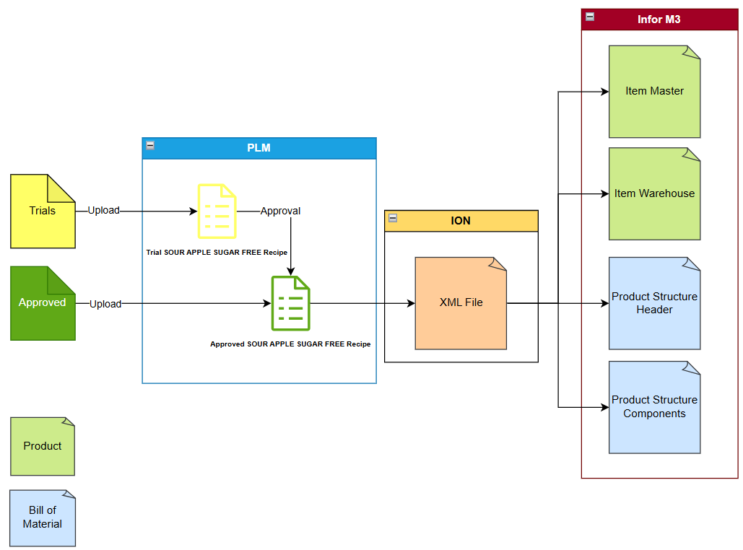
Figure 1: Current integration between PLM to Infor M3

Proposed process
To minimize duplication of tasks in PLM and Infor M3, a modification is proposed to pick up the information from an XML (Extensible Markup Language) file which gets pushed from PLM to Intelligent Open Network (ION) and feed into Infor M3 APIs to update Infor M3. This will be accommodated by mapping the relevant information on the XML to Infor M3 APIs.

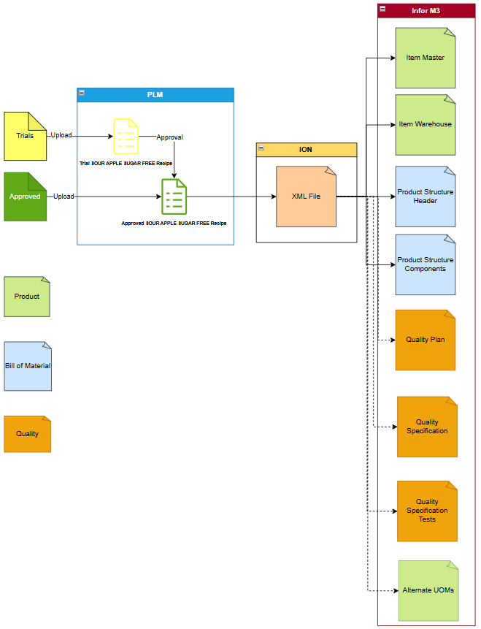
Figure 2: Proposed integration between PLM and Infor M3 with dotted lines highlighting the role of the modification.

Below is the sequence being which APIs to be executed.
Based on the SyncBillOfMaterilas BOD published to OneView, M3_ItemMaster_Acknowledge_Out MeC job needs to have been successfully finished for the process to initiate.

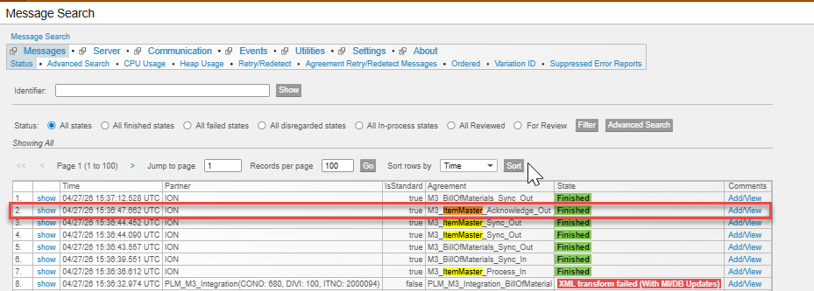

Acknowledge,ItemMaster generated would confirm successful creation of the item code in M3. SyncBillOfMaterials BOD (Business Object Document), <ID> element, holds the item number, which is located at the XML path <SyncBillOfMaterials><DataArea><BillOfMaterials><BillOfMaterialsHeader><DocumentID><ID> and this needs to align with the <ID> element, which is located at the XML path <AcknowledgeItemMaster><DataArea><ItemMaster><ItemMasterHeader><ItemID>.

Step 01: Ensuring the item is successfully created in M3.
  - API: MMS200MI
  - Transaction: Get
Description | Field | Test Value | Extraction Method
Item number | ITNO | 1700330 | In the SyncBillOfMaterials BOD (Business Object Document), the <ID> element, which holds the item number, is located at the XML path <SyncBillOfMaterials><DataArea><BillOfMaterials><BillOfMaterialsHeader><DocumentID><ID>
Table 1: Inputs to validate item creation
If Table 1 generates a record, proceed to step 2. Else stop the process.

Step 02: Creating a quality plan for the recipe.
  - API: QMS009MI
  - Transaction: AddQualityPlan
Description | Field | Test Value | Extraction Method
Quality plan | QLPN | RECIPE | Maintain as a configurable field in a parameter file if needs amending later
Item number | ITNO | 1700330 | In the SyncBillOfMaterials BOD (Business Object Document), the <ID> element, which holds the item number, is located at the XML path <SyncBillOfMaterials><DataArea><BillOfMaterials><BillOfMaterialsHeader><DocumentID><ID>
Description | TX40 | 1700330 | In the SyncBillOfMaterials BOD (Business Object Document), the <ID> element, which holds the item number, is located at the XML path <SyncBillOfMaterials><DataArea><BillOfMaterials><BillOfMaterialsHeader><DocumentID><ID>.
Active | ACTF | 1 | Maintain as a configurable field in a parameter file if needs amending later
Changing QI request | QIMD | 2 | Maintain as a configurable field in a parameter file if needs amending later
Adding test to QI req | QIAT | 1 | Maintain as a configurable field in a parameter file if needs amending later
Spec approval basis | QPLN | 0 | Maintain as a configurable field in a parameter file if needs amending later
QI req appr basis | QPLT | 0 | Maintain as a configurable field in a parameter file if needs amending later
Approval passed/passed | QAPP | 1 | Maintain as a configurable field in a parameter file if needs amending later
Approval passed/failed | QAPF | 1 | Maintain as a configurable field in a parameter file if needs amending later
Approval passed/not tested | QAPN | 1 | Maintain as a configurable field in a parameter file if needs amending later
Approval passed/none | QAPE | 1 | Maintain as a configurable field in a parameter file if needs amending later
Approval failed/passed | QAFP | 3 | Maintain as a configurable field in a parameter file if needs amending later
Approval failed/failed | QAFF | 3 | Maintain as a configurable field in a parameter file if needs amending later
Approval failed/not tested | QAFN | 3 | Maintain as a configurable field in a parameter file if needs amending later
Approval failed/none | QAFE | 3 | Maintain as a configurable field in a parameter file if needs amending later
Approval not tested/passed | QANP | 3 | Maintain as a configurable field in a parameter file if needs amending later
Approval not tested/passed | QANF | 3 | Maintain as a configurable field in a parameter file if needs amending later
Approval not tested/not tested | QANN | 3 | Maintain as a configurable field in a parameter file if needs amending later
Approval not tested/none | QANE | 3 | Maintain as a configurable field in a parameter file if needs amending later
Approval none/passed | QAEP | 3 | Maintain as a configurable field in a parameter file if needs amending later
Approval none/failed | QAEF | 3 | Maintain as a configurable field in a parameter file if needs amending later
Approval none/not tested | QAEN | 3 | Maintain as a configurable field in a parameter file if needs amending later
Lot auto-approval | QLTA | 1 | Maintain as a configurable field in a parameter file if needs amending later
Spec auto-approval | QSPA | 1 | Maintain as a configurable field in a parameter file if needs amending later
QI request auto-approval | QIRA | 1 | Maintain as a configurable field in a parameter file if needs amending later
QI request level | QRLV | 1 | Maintain as a configurable field in a parameter file if needs amending later
Manual QI req status | QST1 | 1 | Maintain as a configurable field in a parameter file if needs amending later
Default QI req as test at pre-ship | TPS2 | 0 | Maintain as a configurable field in a parameter file if needs amending later
Test freq basis for PO | QIFR | 0 | Maintain as a configurable field in a parameter file if needs amending later
Replace PO QI request | QIRP | 0 | Maintain as a configurable field in a parameter file if needs amending later
Test freq basis for MO | QIF1 | 1 | Maintain as a configurable field in a parameter file if needs amending later
Replace MO QI request | QIPF | 1 | Maintain as a configurable field in a parameter file if needs amending later
Create QI request on CO returns | QCRF | 0 | Maintain as a configurable field in a parameter file if needs amending later
Copy QI request on new lot | QCRO | 0 | Maintain as a configurable field in a parameter file if needs amending later
Auto-reinspection of lots | QARE | 0 | Maintain as a configurable field in a parameter file if needs amending later
QI reinspection level | QARL | 0 | Maintain as a configurable field in a parameter file if needs amending later
Reinspection generation basis | QARB | 0 | Maintain as a configurable field in a parameter file if needs amending later
Reinspection calculation date | QARD | 0 | Maintain as a configurable field in a parameter file if needs amending later
Manual update of calculated test | QMTU | 0 | Maintain as a configurable field in a parameter file if needs amending later
Table 2: Inputs to create a quality plan for the recipe.
In the event a quality plan is successfully created for the recipe, the output would one. In the event a quality plan already exists, and an error is generated, bypass the error and proceed to Step 03.

Step 03: Creating a specification header for the recipe.
  - API: QMS200MI
  - Transaction: AddSpec
Description | Field | Test Value | Extraction Method
Specification | SPEC | MIXING | Maintain as a configurable field in a parameter file if needs amending later
Item number | ITNO | 1700330 | In the SyncBillOfMaterials BOD (Business Object Document), the <ID> element, which holds the item number, is located at the XML path <SyncBillOfMaterials><DataArea><BillOfMaterials><BillOfMaterialsHeader><DocumentID><ID>
Date | QSE1 | 20250101 | In the SyncBillOfMaterials BOD, the <StartDateTime> element, which holds the start date, is located at the XML path <SyncBillOfMaterials><DataArea><BillOfMaterials><BillOfMaterialsHeader><Status><TimePeriod><StartDateTime>
Inactive date | QSI1 | 20261231 | In the SyncBillOfMaterials BOD, the <EndDateTime> element, which holds the end date, is located at the XML path <SyncBillOfMaterials><DataArea><BillOfMaterials><BillOfMaterialsHeader><Status><TimePeriod><EndDateTime>
Description | TX40 | 1700330 | In the SyncBillOfMaterials BOD (Business Object Document), the <ID> element, which holds the item number, is located at the XML path <SyncBillOfMaterials><DataArea><BillOfMaterials><BillOfMaterialsHeader><DocumentID><ID>. Maintain as a configurable field in a parameter file if needs amending later
Status | STAT | 20 | Maintain as a configurable field in a parameter file if needs amending later
Spec type | SPET | 0 | Maintain as a configurable field in a parameter file if needs amending later
Retest | SRTT | 1 | Maintain as a configurable field in a parameter file if needs amending later
Reclassification | SRCL | 0 | Maintain as a configurable field in a parameter file if needs amending later
Auto-attach | AUAT | 1 | Maintain as a configurable field in a parameter file if needs amending later
Laboratory manager | SPAN | MOVEX | Maintain as a configurable field in a parameter file if needs amending later
Number of copies | NBEX | 1 | Maintain as a configurable field in a parameter file if needs amending later
Table 3: Inputs to create the specification header against the recipe code.
In the event the specification header is successfully created for the item, the output would be one. Specification name is set to ‘MIXING’ while the description on the specification will align with the recipe code. In the event a specification against the same item for the same effective period (From and To date range) exists in Infor M3, the record will not be created in Infor M3. While the laboratory manager is set to MOVEX, approved by will consume the <SPEC_ISSUE> on the BOD. However, in the event approved by user ID is in status 90: Deactivated in Infor M3, user ID ‘MOVEX’ will be used instead.

Step 04: Mapping test names in M3 to the BOD
This needs to be executed in a loop for each <ID> value within <Specification type="attribute"> record.
- API: CRS881MI
- Transaction: GetTranslData
Description | Field | Test Value | Extraction Method
Record Type | TRQF | 1 | Maintain as a configurable field in the parameter file
Message Standard | MSTD | PLM | Maintain as a configurable field in the parameter file
Message version | MVRS | 1 | Maintain as a configurable field in the parameter file
Business message | BMSG | BillOfMaterials | Maintain as a configurable field in the parameter file
Inbound or outbound message | IBOB | I | Maintain as a configurable field in the parameter file
Parent element(s) | ELMP | Specification | Maintain as a configurable field in the parameter file
Data element | ELMD | Attribute | Maintain as a configurable field in the parameter file
External partner address | EXTP | BRIX | In the SyncBillOfMaterials BOD, the <ID> element, which holds the quantitative quality test name, is located at the XML path <SyncBillOfMaterials><DataArea><BillOfMaterials><BillOfMaterialsHeader><OutputItem>  <Specification type="attribute"><  ID>
Message data | MBMD | SpecificationAttribute | Maintain as a configurable field in the parameter file
Table 4: Inputs to map test name on the BOD to in M3.
Based on inputs to Table 4, below outputs are obtained.

Description | Field | Test Value
Movex data | MVXD | BRIX
Table 5: Quality test name in M3.

Step 05: Extract quantitative test details. This needs to be executed in a loop for each quantitative quality test name that is retrieved as an output in Table 5.
- API: CMS100MI
- Transaction: LstTestDetail
Description | Field | Test Value | Extraction Method
Test | QTQTST | ACIDITY | Movex data output field in Table 5.
Table 6: Inputs to extract quantitative test details for each quality test transferred from PLM.
Based on inputs to Table 6, below outputs are obtained.

Description | Field | Test Value
Test | QTQTST | ACIDITY
Test type | QTTSTY | 0
Effective date | QTQTE1 | 010125
Inactive date | QTQTI1 | 311228
Description | QTTX40 | Acidity check
Test order | QTEXSQ | 1
Test result | QTQLCD
Test U/M | QTTEUM | N/A
Required | QTREQD | 1
Spec appro rule | QTSARL | 0
Value setup | QTVLTP | 1
Test priority | QTQTSP | 1
No. dec places | QTDCCD | 2
Sampling reqd | QTSMPR | 0
Int test reqd | QTINTR | 0
Frequency per | QTFRPR | 0
Frequency times | QTFRTI | 1
Frequency qty | QTFRQY | 0
Frequency U/M | QTFRUM
Sample size | QTSMSZ | 0
Sample U/M | QTSMUM
Destructive tes | QTDSSM | 0
Retain sample | QTRTSM | 0
Calc by frmla | QTTCAL | 0
Test class | QTTCLS | PHYSICAL
Text ID | QTTXID | 0
Spec appro bas | QTQPLN | 0
Table 7: Output from CMS100MI: LstTestDetail

Step 06: Adding quantitative quality tests against the specification.
Below are the inputs to add a quantitative test. This will represent all quality tests retrieved from CRS881MI: GetTranslData in Table 5.

  - API: QMS201MI
  - Transaction: AddSpecTest
Description | Field | Test Value | Extraction Method
Specification | SPEC | MIXING | Maintain as a configurable field in a parameter file if needs amending later
Effective Date | QSE1 | 20250101 | In the SyncBillOfMaterials BOD, the <StartDateTime> element, which holds the start date, is located at the XML path <SyncBillOfMaterials><DataArea><BillOfMaterials><BillOfMaterialsHeader><Status><TimePeriod><StartDateTime>
Item number | ITNO | 1700330 | In the SyncBillOfMaterials BOD (Business Object Document), the <ID> element, which holds the item number, is located at the XML path <SyncBillOfMaterials><DataArea><BillOfMaterials><BillOfMaterialsHeader><DocumentID><ID>
Test | QTST | ACIDITY | QTST from Table 7
Test type | TSTY | 0 | TSTY from Table 7
Effective date | QTE1 | 20250101 | QTE1 from Table 7
Inactive date | QTI1 | 20261231 | QTI1 from Table 7
Description | TX40 | ACIDITY | TX40 from Table 7
Test order | EXSQ | 1 | EXSQ from Table 7
Value setup | VLTP | 1 | VLTP from Table 7
Test priority | QTSP | 1 | QTSP from Table 7
Expected value max | EVMX | 1 | In the SyncBillOfMaterials BOD, the <MaxValue> element, which holds the maximum value on the quality test, is located at the XML path <SyncBillOfMaterials><DataArea><BillOfMaterials><BillOfMaterialsHeader><OutputItem>  <Specification type="attribute"><ID>{’QTQTST’ in Table 7}<NameValue name={’QTQTST’ in Table 7} type="Max Value"></NameValue></Property></Specification>
Expected value min | EVMN | 3 | In the SyncBillOfMaterials BOD, the <MinValue> element, which holds the minimum value on the quality test, is located at the XML path <SyncBillOfMaterials><DataArea><BillOfMaterials><BillOfMaterialsHeader><OutputItem>  <Specification type="attribute"><ID>{’QTQTST’ in Table 7}<NameValue name={’QTQTST’ in Table 7} type="Min Value"></NameValue></Property></Specification>
Expected target value | EVTG | 2 | In the SyncBillOfMaterials BOD, the <NameValue> element, which holds the target value on the quality test, is located at the XML path <SyncBillOfMaterials><DataArea><BillOfMaterials><BillOfMaterialsHeader><OutputItem>  <Specification type="attribute"><ID>{’QTQTST’ in Table 7}<NameValue name={’QTQTST’ in Table 7} type="Actual Value"></NameValue></Property></Specification>
Test U/M | TEUM | OUN | TEUM from Table 7
Number of decimal places | DCCD | 2 | DCCD from Table 7
Required | REQD | 1 | REQD from Table 7
Sampling required | SMPR | 0 | SMPR from Table 7
Internal test required | INTR | 0 | INTR from Table 7
Frequency per | FRPR | 0 | FRPR from Table 7
Frequency times | FRTI | 1 | FRTI from Table 7
Frequency quantity | FRQY | 0 | FRQY from Table 7
Frequency U/M | FRUM | OUN | FRUM from Table 7
Sample size | SMSZ | 0 | SMSZ from Table 7
Sample U/M | SMUM | OUN | SMUM from Table 7
Discard sample | DSSM | 0 | DSSM from Table 7
Retain sample | RTSM | 0 | RTSM from Table 7
Calculated by formula | TCAL | 0 | TCAL from Table 7
Test classification | TCLS | PHYSICAL | TCLS from Table 7
Text identity | TXID | 1 | TXID from Table 7
Include test in QI request | ITQR | 1 | Maintain as a configurable field in a parameter file if needs amending later
Print test on certificate of analysis | PTCA | 1 | Maintain as a configurable field in a parameter file if needs amending later
Print test on specification document | PTSP | 1 | Maintain as a configurable field in a parameter file if needs amending later
Sample usage | DUSM | 0 | Maintain as a configurable field in a parameter file if needs amending later
Print spec test values | QPTT | 1 | Maintain as a configurable field in a parameter file if needs amending later
Print result value | QPTR | 1 | Maintain as a configurable field in a parameter file if needs amending later
Copy DO results | CDOR | 0 | Maintain as a configurable field in a parameter file if needs amending later
Specification approval basis rule | SARL | 0 | SARL from Table 7
Specification approval basis | QPLN | 9 | QPLN from Table 7
Table 8: Inputs to add each quantitative test to the specification.

Step 07: Retrieving qualitative tests.
- API: CRS881MI
- Transaction: LstTranslDataIB
Description | Field | Test Value | Extraction Method
Record Type | TRQF | 1 | Maintain as a configurable field in the parameter file
Message Standard | MSTD | PLM | Maintain as a configurable field in the parameter file
Message version | MVRS | 1 | Maintain as a configurable field in the parameter file
Business message | BMSG | QUALITATIVE | Maintain as a configurable field in the parameter file
Parent element(s) | ELMP | QualitativeTests | Maintain as a configurable field in the parameter file
Data element | ELMD | QualitativeTests | Maintain as a configurable field in the parameter file
External partner address | EXTP | APPEARANCE | In the SyncBillOfMaterials BOD (Business Object Document), the <ID> element, which holds the test name, is located at the XML path  <SyncBillOfMaterials><DataArea><BillOfMaterials><BillOfMaterialsHeader><OutputItem>  <Specification type="attribute"><ID><NameValue name>type="Actual Value"></NameValue></Property></Specification>
Table 9: Inputs to retrieve qualitative tests
Based on inputs to Table 9, below outputs are obtained.

Description | Field | Test Value
Movex data | MVXD | APPEARANCE
Message data | MBMD | Quantitative tests
Table 10: Qualitative tests in use

Step 08: Retrieving details against qualitative quality tests
- API: CMS100MI
- Transaction: LstTestDetail
Description | Field | Test Value | Extraction Method
Test | QTQTST | APPEARANCE | Movex data output field in Table 10
Table 11: Inputs to extract qualitative test details for each quality test transferred from PLM.
Based on inputs to Table 11, below outputs are obtained.

Description | Field | Test Value
Test | QTQTST | APPEARANCE
Test type | QTTSTY | 2
Effective date | QTQTE1 | 010124
Inactive date | QTQTI1 | 271230
Description | QTTX40 | Cloudy Colourless Liquid
Test order | QTEXSQ | 1
Test result | QTQLCD | OK
Test U/M | QTTEUM | N/A
Required | QTREQD | 1
Spec appro rule | QTSARL | 0
Value setup | QTVLTP | 1
Test priority | QTQTSP | 1
No. dec places | QTDCCD | 0
Sampling reqd | QTSMPR | 0
Int test reqd | QTINTR | 0
Frequency per | QTFRPR | 0
Frequency times | QTFRTI | 1
Frequency qty | QTFRQY | 0
Frequency U/M | QTFRUM
Sample size | QTSMSZ | 0
Sample U/M | QTSMUM
Destructive tes | QTDSSM | 0
Retain sample | QTRTSM | 0
Calc by frmla | QTTCAL | 0
Test class | QTTCLS | PHYSICAL
Text ID | QTTXID | 0
Spec appro bas | QTQPLN | 9
Table 12: Output from CMS100MI: LstTestDetail

Step 09: Adding qualitative quality tests against the specification.
Below are the inputs to add a qualitative test. This information is not transferred from PLM and is maintained in M3.
  - API: QMS201MI
  - Transaction: AddSpecTest
Description | Field | Test Value | Extraction Method
Specification | SPEC | MIXING | Maintain as a configurable field in a parameter file if needs amending later
Effective Date | QSE1 | 20250101 | In the SyncBillOfMaterials BOD, the <StartDateTime> element, which holds the start date, is located at the XML path <SyncBillOfMaterials><DataArea><BillOfMaterials><BillOfMaterialsHeader><Status><TimePeriod><StartDateTime>
Item number | ITNO | 1700330 | In the SyncBillOfMaterials BOD (Business Object Document), the <ID> element, which holds the item number, is located at the XML path <SyncBillOfMaterials><DataArea><BillOfMaterials><BillOfMaterialsHeader><DocumentID><ID>
Test | QTST | TASTE | QTST from Table 12
Test type | TSTY | 2 | TSTY from Table 12
Effective date | QTE1 | 20250101 | QTE1 from Table 12
Inactive date | QTI1 | 20261231 | QTI1 from Table 12
Description | TX40 | ACIDITY | In the SyncBillOfMaterials BOD, the <NameValue> element, which holds the test description is located at the XML path <SyncBillOfMaterials><DataArea><BillOfMaterials><BillOfMaterialsHeader><OutputItem>  <Specification type="attribute"><ID>{’QTQTST’ in Table 12}<NameValue name={’QTQTST’ in Table 12} type="Actual Value"></NameValue></Property></Specification>
Test order | EXSQ | 1 | EXSQ from Table 12
Test result | QLCD | OK | Maintain as a configurable field in a parameter file if needs amending later
Value setup | VLTP | 1 | VLTP from Table 12
Test priority | QTSP | 1 | QTSP from Table 12
Test U/M | TEUM | OUN | TEUM from Table 12
Number of decimal places | DCCD | 0 | DCCD from Table 12
Required | REQD | 1 | REQD from Table 12
Sampling required | SMPR | 0 | SMPR from Table 12
Internal test required | INTR | 0 | INTR from Table 12
Frequency per | FRPR | 0 | FRPR from Table 12
Frequency times | FRTI | 1 | FRTI from Table 12
Frequency quantity | FRQY | 0 | FRQY from Table 12
Frequency U/M | FRUM | OUN | FRUM from Table 12
Sample size | SMSZ | 0 | SMSZ from Table 12
Sample U/M | SMUM | OUN | SMUM from Table 12
Discard sample | DSSM | 0 | DSSM from Table 12
Retain sample | RTSM | 0 | RTSM from Table 12
Calculated by formula | TCAL | 0 | TCAL from Table 12
Test classification | TCLS | PHYSICAL | TCLS from Table 12
Text identity | TXID | 1 | TXID from Table 12
Include test in QI request | ITQR | 1 | Maintain as a configurable field in a parameter file if needs amending later
Print test on certificate of analysis | PTCA | 1 | Maintain as a configurable field in a parameter file if needs amending later
Print test on specification document | PTSP | 1 | Maintain as a configurable field in a parameter file if needs amending later
Sample usage | DUSM | 0 | Maintain as a configurable field in a parameter file if needs amending later
Print spec test values | QPTT | 1 | Maintain as a configurable field in a parameter file if needs amending later
Print result value | QPTR | 1 | Maintain as a configurable field in a parameter file if needs amending later
Copy DO results | CDOR | 0 | Maintain as a configurable field in a parameter file if needs amending later
Specification approval basis rule | SARL | 0 | SARL from Table 12
Specification approval basis | QPLN | 9 | QPLN from Table 12
Table 13: Inputs to add each qualitative test to the specification.

Step 10: Add density as a quality check against recipes where density check is set to 1.
In the event, the value stored against <NameValue> element on ID ‘Density_Check’ is 1, execute below, else skip this step and progress to Step 10.03. In the SyncBillOfMaterials BOD, the <NameValue> element, which holds the value against density check, is located at the XML path <SyncBillOfMaterials><DataArea><BillOfMaterials><BillOfMaterialsHeader><OutputItem>
<Specification type="attribute"><ID> Density_Check</ID><Property><NameValue>

Step 10.01. Retrieve density test details.
- API: CMS100MI
- Transaction: LstTestDetail
Description | Field | Test Value | Extraction Method
Test | QTQTST | DENSITY | Hardcoded
Table 14: Inputs to extract density test details.
Based on inputs to Table 14, below outputs are obtained.

Description | Field | Test Value
Test | QTQTST | DENSITY
Test type | QTTSTY | 0
Effective date | QTQTE1 | 010125
Inactive date | QTQTI1 | 311228
Description | QTTX40 | Density
Test order | QTEXSQ | 1
Test result | QTQLCD
Test U/M | QTTEUM | KGL
Required | QTREQD | 1
Spec appro rule | QTSARL | 0
Value setup | QTVLTP | 1
Test priority | QTQTSP | 1
No. dec places | QTDCCD | 6
Sampling reqd | QTSMPR | 0
Int test reqd | QTINTR | 0
Frequency per | QTFRPR | 0
Frequency times | QTFRTI | 1
Frequency qty | QTFRQY | 0
Frequency U/M | QTFRUM
Sample size | QTSMSZ | 0
Sample U/M | QTSMUM
Destructive tes | QTDSSM | 0
Retain sample | QTRTSM | 0
Calc by frmla | QTTCAL | 0
Test class | QTTCLS | PHYSICAL
Text ID | QTTXID | 0
Spec appro bas | QTQPLN | 0
Table 15: Output from CMS100MI: LstTestDetail

Step 10.02. Adding density as a test against the specification.
  - API: QMS201MI
  - Transaction: AddSpecTest
Description | Field | Test Value | Extraction Method
Specification | SPEC | MIXING | Maintain as a configurable field in a parameter file if needs amending later
Effective Date | QSE1 | 20250101 | In the SyncBillOfMaterials BOD, the <StartDateTime> element, which holds the start date, is located at the XML path <SyncBillOfMaterials><DataArea><BillOfMaterials><BillOfMaterialsHeader><Status><TimePeriod><StartDateTime>
Item number | ITNO | 1700330 | In the SyncBillOfMaterials BOD (Business Object Document), the <ID> element, which holds the item number, is located at the XML path <SyncBillOfMaterials><DataArea><BillOfMaterials><BillOfMaterialsHeader><DocumentID><ID>
Test | QTST | Density | QTST from Table 15
Test type | TSTY | 0 | TSTY from Table 15
Effective date | QTE1 | 20250101 | QTE1 from Table 15
Inactive date | QTI1 | 20261231 | QTI1 from Table 15
Description | TX40 | Density | TX40 from Table 15
Test order | EXSQ | 1 | EXSQ from Table 15
Value setup | VLTP | 1 | VLTP from Table 15
Test priority | QTSP | 1 | QTSP from Table 15
Expected value max | EVMX | 2.2 | In the SyncBillOfMaterials BOD, the <NameValue> element, which holds the value on the quality test, is located at the XML path <SyncBillOfMaterials><DataArea><BillOfMaterials><BillOfMaterialsHeader><OutputItem>  <Specification type="attribute"><ID>Density<NameValue name=Density type="Max Value"></NameValue></Property></Specification>
Expected value min | EVMN | 2 | In the SyncBillOfMaterials BOD, the <NameValue> element, which holds the value on the quality test, is located at the XML path <SyncBillOfMaterials><DataArea><BillOfMaterials><BillOfMaterialsHeader><OutputItem>  <Specification type="attribute"><ID>Density<NameValue name=Density type="Min Value"></NameValue></Property></Specification>
Expected target value | EVTG | 2 | In the SyncBillOfMaterials BOD, the <NameValue> element, which holds the value on the quality test, is located at the XML path <SyncBillOfMaterials><DataArea><BillOfMaterials><BillOfMaterialsHeader><OutputItem>  <Specification type="attribute"><ID>Density<NameValue name=Density type="Actual Value"></NameValue></Property></Specification>
Test U/M | TEUM | OUN | TEUM from Table 15
Number of decimal places | DCCD | 2 | DCCD from Table 15
Required | REQD | 1 | REQD from Table 15
Sampling required | SMPR | 0 | SMPR from Table 15
Internal test required | INTR | 0 | INTR from Table 15
Frequency per | FRPR | 0 | FRPR from Table 15
Frequency times | FRTI | 1 | FRTI from Table 15
Frequency quantity | FRQY | 0 | FRQY from Table 15
Frequency U/M | FRUM | OUN | FRUM from Table 15
Sample size | SMSZ | 0 | SMSZ from Table 15
Sample U/M | SMUM | OUN | SMUM from Table 15
Discard sample | DSSM | 0 | DSSM from Table 15
Retain sample | RTSM | 0 | RTSM from Table 15
Calculated by formula | TCAL | 0 | TCAL from Table 15
Test classification | TCLS | PHYSICAL | TCLS from Table 15
Text identity | TXID | 1 | TXID from Table 15
Include test in QI request | ITQR | 1 | Maintain as a configurable field in a parameter file if needs amending later
Print test on certificate of analysis | PTCA | 1 | Maintain as a configurable field in a parameter file if needs amending later
Print test on specification document | PTSP | 1 | Maintain as a configurable field in a parameter file if needs amending later
Sample usage | DUSM | 0 | Maintain as a configurable field in a parameter file if needs amending later
Print spec test values | QPTT | 1 | Maintain as a configurable field in a parameter file if needs amending later
Print result value | QPTR | 1 | Maintain as a configurable field in a parameter file if needs amending later
Copy DO results | CDOR | 0 | Maintain as a configurable field in a parameter file if needs amending later
Specification approval basis rule | SARL | 0 | SARL from Table 15
Specification approval basis | QPLN | 9 | QPLN from Table 15
Table 16: Inputs to add density as a quality check to the quality specification

Step 10.03: Add Lactic Acid as a quality check against recipes where Lactic check is set to 1.
In the event, the value stored against <NameValue> element on ID ‘LACTIC_ACID_CHECK’ is 1, execute below, else skip this step and progress to Step 11. In the SyncBillOfMaterials BOD, the <NameValue> element, which holds the value against lactic check, is located at the XML path <SyncBillOfMaterials><DataArea><BillOfMaterials><BillOfMaterialsHeader><OutputItem>
<Specification type="attribute"><ID> LACTIC_ACID_CHECK</ID><Property><NameValue>

Step 10.04. Retrieve lactic test details.
- API: CMS100MI
- Transaction: LstTestDetail
Description | Field | Test Value | Extraction Method
Test | QTQTST | LACTIC | Hardcoded
Table 17: Inputs to extract lactic test details.
Based on inputs to Table 17, below outputs are obtained.

Description | Field | Test Value
Test | QTQTST | LACTIC
Test type | QTTSTY | 0
Effective date | QTQTE1 | 010125
Inactive date | QTQTI1 | 311228
Description | QTTX40 | Lactic
Test order | QTEXSQ | 1
Test result | QTQLCD
Test U/M | QTTEUM | KGL
Required | QTREQD | 1
Spec appro rule | QTSARL | 0
Value setup | QTVLTP | 1
Test priority | QTQTSP | 1
No. dec places | QTDCCD | 6
Sampling reqd | QTSMPR | 0
Int test reqd | QTINTR | 0
Frequency per | QTFRPR | 0
Frequency times | QTFRTI | 1
Frequency qty | QTFRQY | 0
Frequency U/M | QTFRUM
Sample size | QTSMSZ | 0
Sample U/M | QTSMUM
Destructive tes | QTDSSM | 0
Retain sample | QTRTSM | 0
Calc by frmla | QTTCAL | 0
Test class | QTTCLS | PHYSICAL
Text ID | QTTXID | 0
Spec appro bas | QTQPLN | 0
Table 18: Output from CMS100MI: LstTestDetail

Step 10.05. Adding lactic acid as a test against the specification.
  - API: QMS201MI
  - Transaction: AddSpecTest
Description | Field | Test Value | Extraction Method
Specification | SPEC | MIXING | Maintain as a configurable field in a parameter file if needs amending later
Effective Date | QSE1 | 20250101 | In the SyncBillOfMaterials BOD, the <StartDateTime> element, which holds the start date, is located at the XML path <SyncBillOfMaterials><DataArea><BillOfMaterials><BillOfMaterialsHeader><Status><TimePeriod><StartDateTime>
Item number | ITNO | 1700330 | In the SyncBillOfMaterials BOD (Business Object Document), the <ID> element, which holds the item number, is located at the XML path <SyncBillOfMaterials><DataArea><BillOfMaterials><BillOfMaterialsHeader><DocumentID><ID>
Test | QTST | Lactic | QTST from Table 18
Test type | TSTY | 0 | TSTY from Table 18
Effective date | QTE1 | 20250101 | QTE1 from Table 18
Inactive date | QTI1 | 20261231 | QTI1 from Table 18
Description | TX40 | Lactic | TX40 from Table 18
Test order | EXSQ | 1 | EXSQ from Table 18
Value setup | VLTP | 1 | VLTP from Table 18
Test priority | QTSP | 1 | QTSP from Table 18
Expected value max | EVMX | 2.2 | In the SyncBillOfMaterials BOD, the <NameValue> element, which holds the value on the quality test, is located at the XML path <SyncBillOfMaterials><DataArea><BillOfMaterials><BillOfMaterialsHeader><OutputItem>  <Specification type="attribute"><ID>LACTIC_ACID<NameValue name=Density type="Max Value"></NameValue></Property></Specification>
Expected value min | EVMN | 2 | In the SyncBillOfMaterials BOD, the <NameValue> element, which holds the value on the quality test, is located at the XML path <SyncBillOfMaterials><DataArea><BillOfMaterials><BillOfMaterialsHeader><OutputItem>  <Specification type="attribute"><ID> LACTIC_ACID<NameValue name=Density type="Min Value"></NameValue></Property></Specification>
Expected target value | EVTG | 2 | In the SyncBillOfMaterials BOD, the <NameValue> element, which holds the value on the quality test, is located at the XML path <SyncBillOfMaterials><DataArea><BillOfMaterials><BillOfMaterialsHeader><OutputItem>  <Specification type="attribute"><ID> LACTIC_ACID<NameValue name=Density type="Actual Value"></NameValue></Property></Specification>
Test U/M | TEUM | OUN | TEUM from Table 18
Number of decimal places | DCCD | 2 | DCCD from Table 18
Required | REQD | 1 | REQD from Table 18
Sampling required | SMPR | 0 | SMPR from Table 18
Internal test required | INTR | 0 | INTR from Table 18
Frequency per | FRPR | 0 | FRPR from Table 18
Frequency times | FRTI | 1 | FRTI from Table 18
Frequency quantity | FRQY | 0 | FRQY from Table 18
Frequency U/M | FRUM | OUN | FRUM from Table 18
Sample size | SMSZ | 0 | SMSZ from Table 18
Sample U/M | SMUM | OUN | SMUM from Table 18
Discard sample | DSSM | 0 | DSSM from Table 18
Retain sample | RTSM | 0 | RTSM from Table 18
Calculated by formula | TCAL | 0 | TCAL from Table 18
Test classification | TCLS | PHYSICAL | TCLS from Table 18
Text identity | TXID | 1 | TXID from Table 18
Include test in QI request | ITQR | 1 | Maintain as a configurable field in a parameter file if needs amending later
Print test on certificate of analysis | PTCA | 1 | Maintain as a configurable field in a parameter file if needs amending later
Print test on specification document | PTSP | 1 | Maintain as a configurable field in a parameter file if needs amending later
Sample usage | DUSM | 0 | Maintain as a configurable field in a parameter file if needs amending later
Print spec test values | QPTT | 1 | Maintain as a configurable field in a parameter file if needs amending later
Print result value | QPTR | 1 | Maintain as a configurable field in a parameter file if needs amending later
Copy DO results | CDOR | 0 | Maintain as a configurable field in a parameter file if needs amending later
Specification approval basis rule | SARL | 0 | SARL from Table 18
Specification approval basis | QPLN | 9 | QPLN from Table 18
Table 19: Inputs to add lactic acid as a quality check to the quality specification

Step 11: Generating an alternate UOM.
  - API: MMS015MI
  - Transaction: Add
Description | Field | Test Value | Extraction Method
Item number | ITNO | 153224 | In the SyncBillOfMaterials BOD (Business Object Document), the <ID> element, which holds the item number, is located at the XML path <SyncBillOfMaterials><DataArea><BillOfMaterials><BillOfMaterialsHeader><DocumentID><ID>
Alternate U/M type | AUTP | 1 | Maintain as a configurable field in a parameter file if needs amending later
Alternate U/M | ALUN | KG | Maintain as a configurable field in a parameter file if needs amending later
Number of decimal places | DCCD | 2 | Maintain as a configurable field in a parameter file if needs amending later
Conversion factor | COFA | 1.032 | In the SyncBillOfMaterials BOD, the <NameValue> element, which holds the conversion factor for density, is located at the XML path <SyncBillOfMaterials><DataArea><BillOfMaterials><BillOfMaterialsHeader><OutputItem>  <Specification type="attribute"><ID>Density</ID><Property><NameValue>
Conversion form | DMCF | 2 | Maintain as a configurable field in a parameter file if needs amending later
Standard U/M - Manufacturing | AUS3 | 1 | Maintain as a configurable field in a parameter file if needs amending later
Table 20: Inputs to add unit of measure conversion between Kilograms and Liters
In the event Step 11 fails due to an existing record, proceed to Step 12, else proceed to Step 13.

Step 12: Updating density against recipe code.
  - API: MMS015MI
  - Transaction: Upd
Description | Field | Test Value | Extraction Method
Item number | ITNO | 153224 | In the SyncBillOfMaterials BOD (Business Object Document), the <ID> element, which holds the item number, is located at the XML path <SyncBillOfMaterials><DataArea><BillOfMaterials><BillOfMaterialsHeader><DocumentID><ID>
Alternate U/M type | AUTP | 1 | Maintain as a configurable field in a parameter file if needs amending later
Alternate U/M | ALUN | KG | Maintain as a configurable field in a parameter file if needs amending later
Number of decimal places | DCCD | 2 | Maintain as a configurable field in a parameter file if needs amending later
Conversion factor | COFA | 1.032 | In the SyncBillOfMaterials BOD, the <NameValue> element, which holds the conversion factor for density, is located at the XML path <SyncBillOfMaterials><DataArea><BillOfMaterials><BillOfMaterialsHeader><OutputItem>  <Specification type="attribute"><ID>Density</ID><Property><NameValue>
Conversion form | DMCF | 2 | Maintain as a configurable field in a parameter file if needs amending later
Standard U/M - Manufacturing | AUS3 | 1 | Maintain as a configurable field in a parameter file if needs amending later
Table 21: Inputs to update unit of measure conversion between Kilograms and Liters

Step 13: Update shelf life against the item.
  - API: MMS200MI
  - Transaction: UpdItmWhs
Description | Field | Test Value | Extraction Method
Item number | ITNO | 153224 | In the SyncBillOfMaterials BOD (Business Object Document), the <ID> element, which holds the item number, is located at the XML path <SyncBillOfMaterials><DataArea><BillOfMaterials><BillOfMaterialsHeader><DocumentID><ID>
Warehouse | WHLO | SIM | Hardcoded
Shelf Life | SLDY | 20 | In the SyncBillOfMaterials BOD, the <NameValue> element, which holds the conversion factor for shelf life, is located at the XML path <SyncBillOfMaterials><DataArea><BillOfMaterials><BillOfMaterialsHeader><OutputItem>  <Specification type="attribute"><ID> SHELF_LIFE_DAYS</ID><Property><NameValue>
Table 22: Inputs to update shelf life against the recipe code.

Error Handling
In the event of an error on the standard integration between PLM to Infor M3, the error needs to be fixed in PLM/ Infor M3, and the record needs to be pushed again from PLM.

However, in the event of an error on the integration such as an API failing to successfully complete, an error email would be generated to a user group notifying the error. Once notified, the error needs to be fixed, and the job needs to be reprocessed.

Assumptions & Limitations
- Quantitative quality test names on PLM and Infor M3 are mapped in CRS881 for recipe items.
- In the event new quantitative quality tests are added to QMS100, CRS881 mapping needs to be updated.
- All recipe codes would include qualitative tests defined in the CRS881 mapping for QualitativeTests.
- In the event new qualitative quality tests are added against recipe items, CRS881 mapping needs to be updated.
- Qualitative quality tests won’t be transmitted from PLM to M3.
- Infor M3 is only able to handle a minimum, maximum and a target value and is not capable in handling ‘<’, ‘>’, plus or minus values.
- Minimum, maximum and target values transferred from PLM to Infor M3 need to align with the correct test type in Infor M3 (i.e. Values a test could hold would depend on whether the test being correctly setup in Infor M3 as a qualitative or a quantitative test).
- The effective period (From and To date) on a quality specification generated against a recipe code will align with the start date and the end date on the bill of material version transferred from PLM to Infor M3.
- When a quality specification is created against an item, if a quality specification already exists in Infor M3 for the same item for the same effective period (From and To date range) the specification will not be created.
- Laboratory Manager will be made equal to an Infor M3 generic ID: ‘MOVEX’ while ‘approved by’ will pick the ‘Spec issued by’ transferred from PLM. In the event, ‘Spec issued by’ is in status 90: Deactivated, a generic user ID: MOVEX will be used.
- For density conversion to be successful, a unit of measure conversion should not already exist in Infor M3 against the item for alternate unit of measure KG.
- If a density is transferred from PLM to Infor M3 for a recipe code, the manufacturing unit of measure against the recipe code will always be KG.
- The logic relevant for output documents related to quality or traceability arising because of this integration is outside the scope of this specification and will be undertaken separately.
- The user group that needs notifying about an API failure is determined by Simpsons and communicated to Anthesis.
- Standard error handling will apply when data flow from PLM to Infor M3.
- API errors will need to be handled on the integration between PLM and Infor M3.

